Inspection Report |  | Report No. | CW-20120319-CLS-001
PRODUCT DESCRIPTION
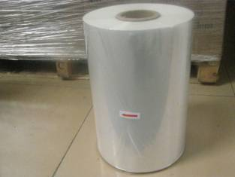  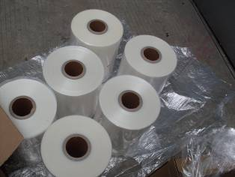 | Client Name: Sultan Triveni General Trading & Contracting
 | Product Name: POF centerfolded film
 | Inspector: Richard Li
 | Report approver:
 | Inspection location: |  |  | SHENZHEN,GUANGDONG,CHINA
 | Inspection date: |  |  | 19/Mar/2012
 | Your reference number: N/A
 | P/O number: ST-044-2011
 | Inspection type : Container loading supervision(CLS)
 | Supplier: Hubei Guancheng Biodegradable Plastic Products Co. Ltd
 | Vendor: Hubei Guancheng Biodegradable Plastic Products Co. Ltd
 | Order quantity : 720Rolls |  |  | See attached table
 | Pcs ready for inspection: |  |  | 100% ready
 | Reference sample available: |  |  | NO

Factory cooperation | Factory organization | Inspector’s opinion on the factory
Average | Average | Average

Loading starting time | Loading completion time
16 :10 | 17 :40

IMPORTANT REMARKS / GENERAL DEFECTS
- For all of items, actually found the net weight and gross weight were described differently on each of shipping box, but we could not check it due to no suitable equipment provided.( Pls. Refer to remark photos)
- Actually found the cargo were placed on 15 pallets in total to loading, which did not conform to client’s instruction as 30 pallets in total. However, the carrier claimed that the products could not load in container completely if according to client required as 30 rolls per pallet, but now it does by current stacking way. (Pls. refer to the below item ‘Loading Videos’ of page 14 ‘)

LOADING AND PACKING REQUIREMENTS
1. Loaded Quantity
Expected Result | Result | Actual Finding / Comments
Total nb of Container(s) loaded：  20”： / 40” ： / 40” HC ： | Subject to client’s decision | 20” HC
Total nb of Pallets loaded： | Pending due to remark | 15 pallets
Total nb of Cartons loaded： | Conform | 720 cartons
Numbering of cartons：( to ) | Subject to client’s decision | No carton number found.
TOTAL NUMBER OF PIECES READY : |  | 100% ready and see below attached table
Truck plate numbers |  | 粤BG5730

The attached table:
Container No | Product description | CTN Q’TY | Q’TY (pcs) | SEAL NO.
HJCU2911605 | 1#250/500MMX1067MX19MU | 90 ctns | 90 pcs | HAN JIN CH8316169
HJCU2911605 | 2#300/600MMX1067MX19MU | 90 ctns | 90 pcs | HAN JIN CH8316169
HJCU2911605 | 3#350/700MMX1067MX19MU | 90ctns | 90 pcs | HAN JIN CH8316169
HJCU2911605 | 4#400/800MMX1067MX19MU | 60ctns | 60 pcs | HAN JIN CH8316169
HJCU2911605 | 5#450/900MMX1067MX19MU | 60ctns | 60 pcs | HAN JIN CH8316169
HJCU2911605 | 6#300/600MMX800MX25MU | 90ctns | 90 pcs | HAN JIN CH8316169
HJCU2911605 | 7#350/700MMX800MX25MU | 60ctns | 60 pcs | HAN JIN CH8316169
HJCU2911605 | 8#400/800MMX800MX25MU | 90ctns | 90 pcs | HAN JIN CH8316169
HJCU2911605 | 9#450/900MMX800MX25MU | 90ctns | 90 pcs | HAN JIN CH8316169
HJCU2911605 | 10#500/1000MMX800MX25MU | 30 ctns | 30 pcs | HAN JIN CH8316169

2. Shipping Marks
a. Carton Front Mark
Expected Result | Result |  | Actual Finding / Comments
 | Subject to client’s decision |  | Refer to product photos
b. Carton Side Mark
Expected Result | Result |  | Actual Finding / Comments
 | Subject to client’s decision |  | Refer to product photos

3. Loading Process
Client’s specific instructions for Loading Process :
N/A
EMPTY CONTAINER
Requested Check | Actual Finding / Comments
Container general conditions :  - water  - rust holes  - dust  - grease  - general cleanliness | - no water  - no rust holes  - clean  - no grease
Container door numbers | HJCU2911605
Inside container numbers
Outside container numbers
1/4 FULL CONTAINER
Requested Check | Actual Finding / Comments
Loading method :  - By hand or machine  - Pallets or individual carton | -By hand & machine  - Individual carton & pallets
Loading by the top or the back of the truck? | Loading by the back
Describe how the cartons are piled up (collapse risks) | Refer to photo below
How many layers of cartons inside the container ? | 5 layers
Did any cartons fell on the floor during loading? | No
1/2 FULL CONTAINER
Requested Check | Actual Finding / Comments
Did any cartons fell on the floor during loading? | No
3/4 FULL CONTAINER
Requested Check | Actual Finding / Comments
Did any cartons fell on the floor during loading? | No
FULL CONTAINER
Requested Check | Actual Finding / Comments
Is the container completely full? If no, describe how carton are tied together. | Yes, there is. The detail for reason pls. refer to remark and loading photos.
Is there any space between the top of the last layer of cartons and the roof of the container ? | Yes, there is. The detail for reason pls. refer to remark and loading photos.
Container(s) seals number | HAN JIN CH8316169
Did any cartons fell on the floor during loading? | No
CONTAINER CLOSING
Requested Check | Actual Finding / Comments
Are seals temporary or definitive? | Definitive seals
Remark photos
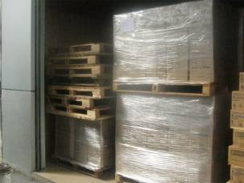 |  | 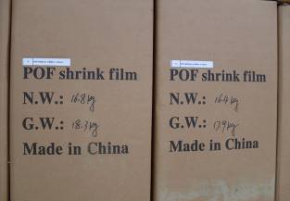
For all of items, actually found the net weight and gross weight were described differently on each of shipping box, but we could not check it due to no suitable equipment provided

PRODUCT PHOTOS
Expected Result | Result |  | Actual Finding / Comments
 | N/A |  | Please see picture
Pictures:
Item No.: 1#250/500MMX1067MX19MU Order quantity: 90ctns
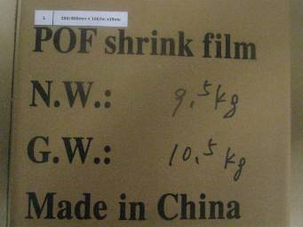 |  | 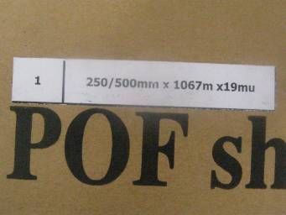
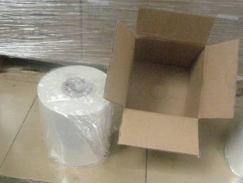 |  | 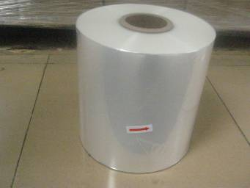
Item No.: 2#300/600MMX1067MX19MU Order quantity: 90ctns
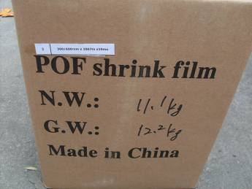 |  | 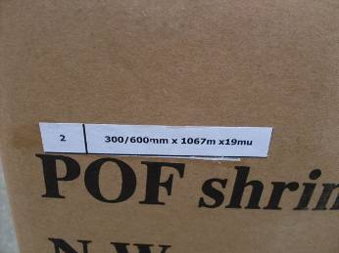
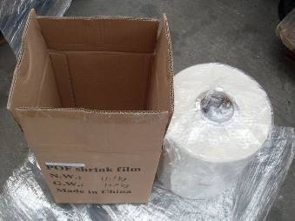 |  | 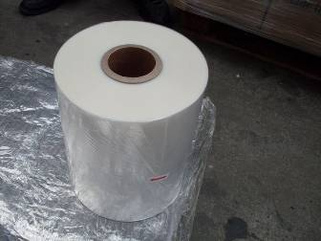
Item No.: 3# 350/700MMX1067MX19MU Order quantity: 90ctns
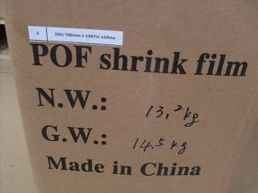 |  | 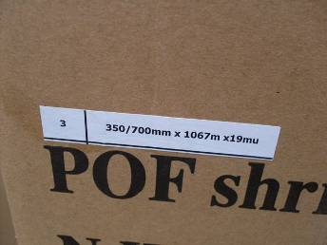
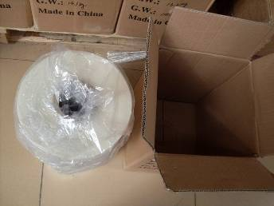 |  | 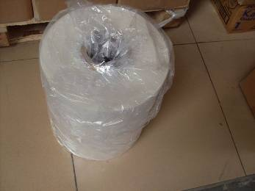
Item No.: 4#400/800MMX1067MX19MU Order quantity: 60 ctns
 |  | 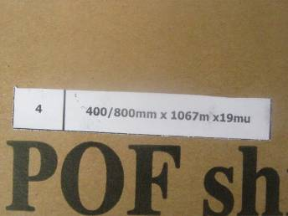
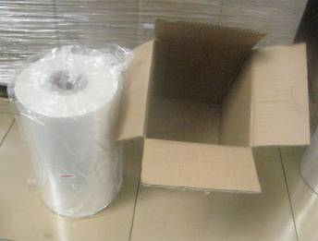 |  | 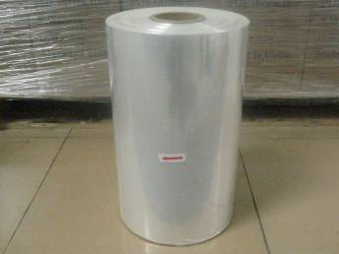
Item No.: 5#450/900MMX1067MX19MU Order quantity: 60 ctns
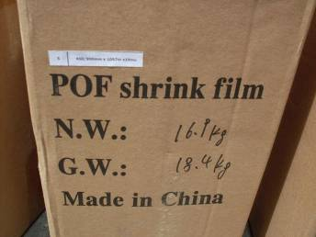 |  | 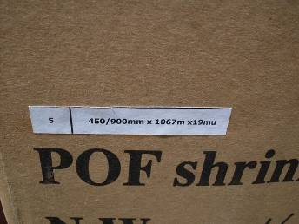
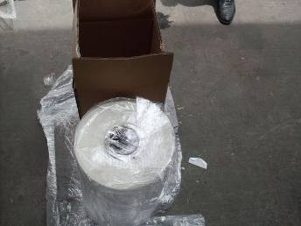 |  | 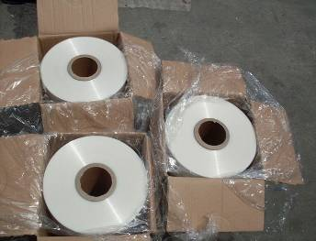
Item No.: 6#300/600MMX800MX25MU Order quantity: 90 ctns
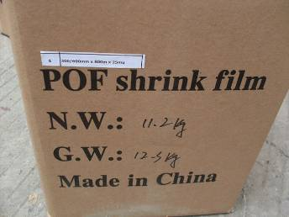 |  | 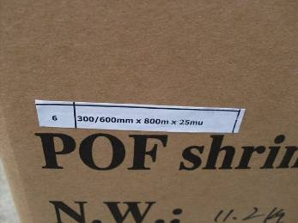
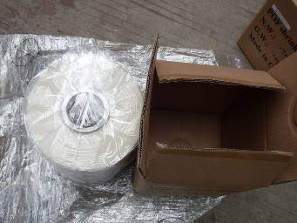 |  | 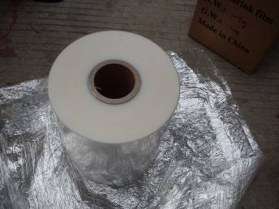
Item No.: 7#350/700MMX800MX25MU Order quantity: 60 ctns
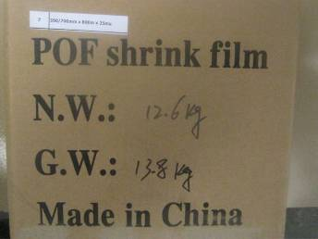 |  | 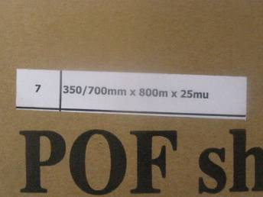
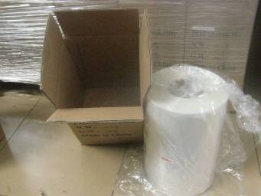 |  | 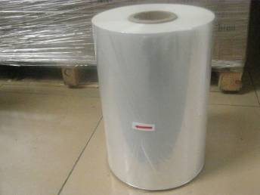
Item No.: 8#400/800MMX800MX25MU Order quantity: 90 ctns
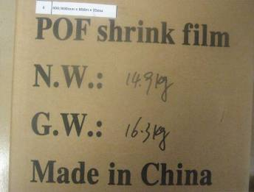 |  | 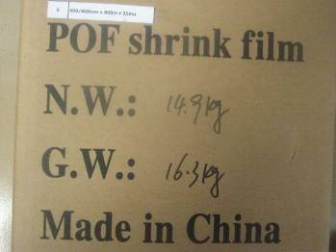
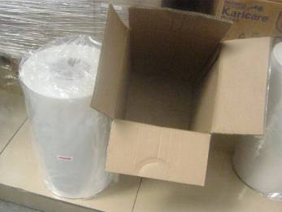 |  | 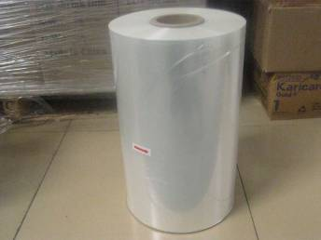
Item No.: 9#450/900MMX800MX25MU Order quantity: 90 ctns
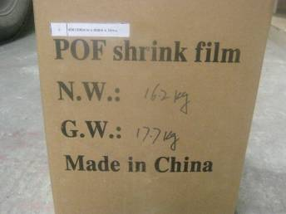 |  | 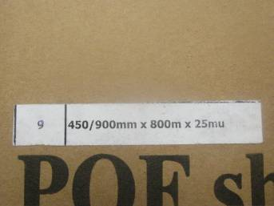
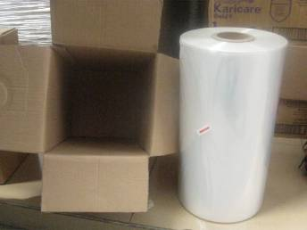 |  | 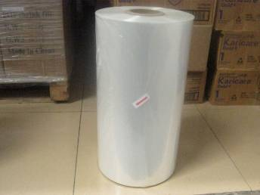
Item No.: 10#500/1000MMX800MX25MU Order quantity: 30 ctns
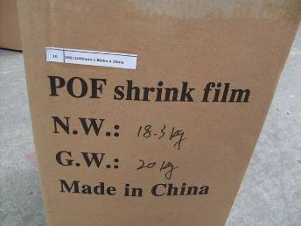 |  | 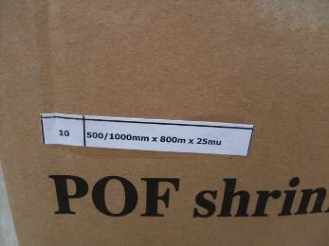
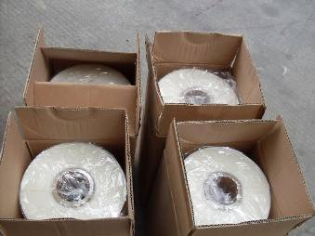 |  | 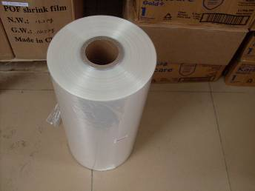

Loading Pictures:
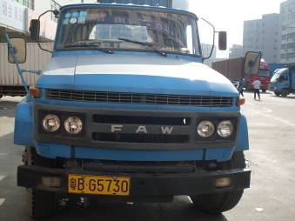  Container | 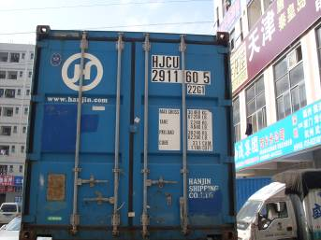  Container door number
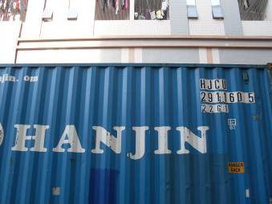  Container outside | 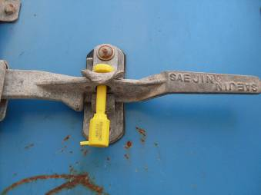  Seal
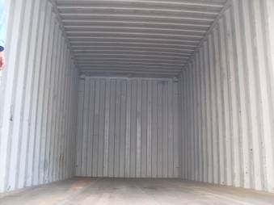  Empty container | 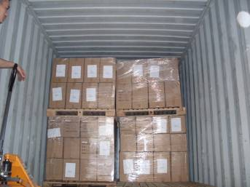  1/4 Full container
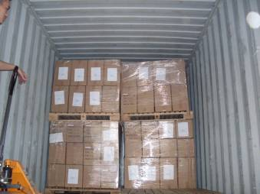  1/2 Full container | 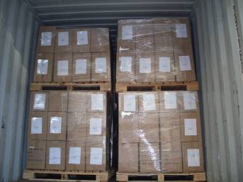  3/4 Full container
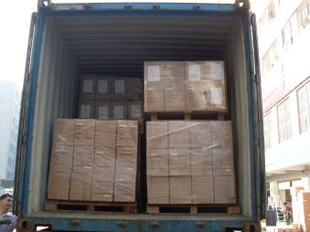  Full container | 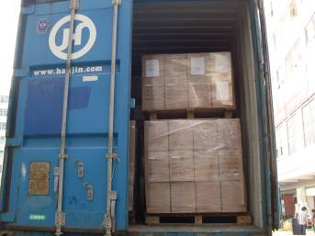  Left door of the container
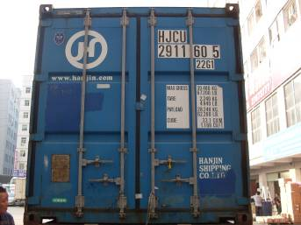  Closed container | 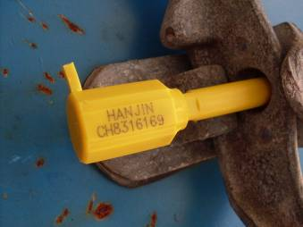  Seal detail on container

c. Outer packing:
Sealing method (staples - adhesive - plastic band - metal band): adhesive
Expected Result | Result |  | Actual Finding / Comments
 | Subject to client’s decision |  | Refer to below pictures
Photos
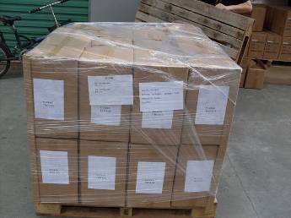 |  | 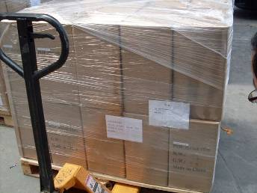
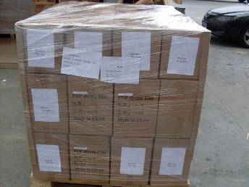 |  | 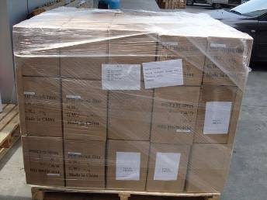
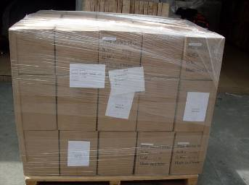 |  | 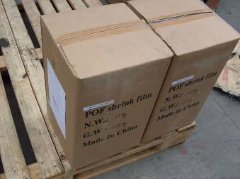

Loading Videos
The products in the warehouse | Full container

Other Photos
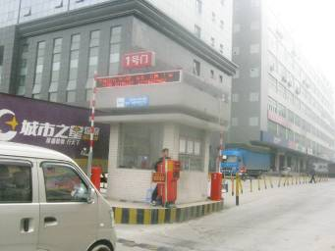 | 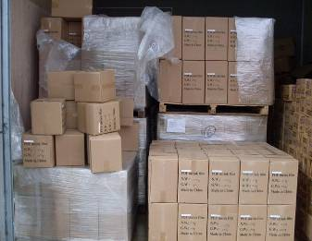
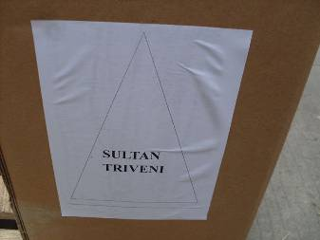 | 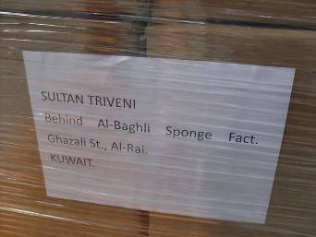
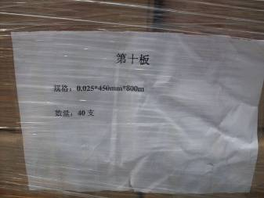 | 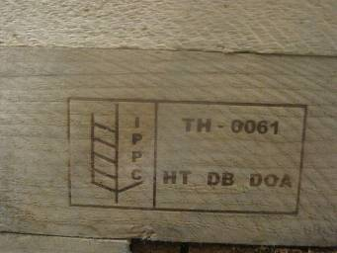

End of the Report

